Problem Statement:
Public bike-sharing systems generate continuous data from hundreds of stations across different cities. The task is to analyze this real-time bike station dataset to understand station performance, usage efficiency, and operational patterns across cities.
Applying Power BI skills—from data cleaning and modeling to DAX and dashboarding—to turn raw data into actionable urban mobility insights.

Dataset:
Source: Dataset link
You can document your Power BI Data Cleaning process like this (simple and professional for interview or project report).

Tool Used
- Microsoft Power BI (Power Query Editor)

Data Cleaning Steps Performed

Data Import
The dataset was imported into Power BI using Get Data → Excel and opened in Power Query Editor for transformation.
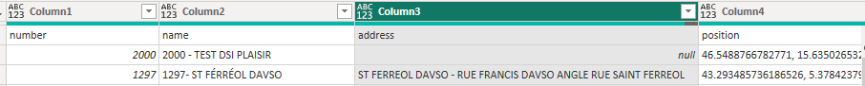

Promoted Headers
The first row of the dataset was promoted to column headers to correctly label the dataset fields.

Changed Data Types
Appropriate data types were assigned to columns to ensure accurate analysis.
Column | Data Type
Station_ID | Whole Number
Station_Name | Text
Contract_Name | Text
Total_Bike_Stands | Whole Number
Available_Bikes | Whole Number
Empty_Stands | Whole Number
Status | Text
Last_Update | Date/Time
Latitude | Decimal
Longitude | Decimal

Renamed Columns
Column names were renamed to improve clarity and maintain consistent naming conventions.
Example:
- number → Station_ID
- name → Station_Name

Split Column by Delimiter
The position column, which contained combined latitude and longitude values, was split using a comma delimiter.
This created two new columns:
- Latitude
- Longitude
These columns are used for map visualizations.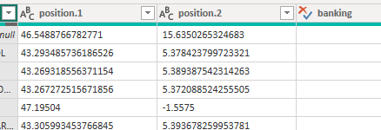

Text Standardization
Text fields were cleaned and standardized to ensure consistency.
Steps performed:
- Trimmed Text to remove extra spaces
- Cleaned Text to remove non-printable characters
- Capitalized Each Word for uniform formatting

Reordered Columns
Columns were reordered to maintain a logical structure for analysis.

Removed Unnecessary Columns
Columns that were not required for analysis were removed to simplify the dataset.
Address column was removed since geographic coordinates (Latitude and Longitude) were already available for mapping.

Final Dataset
The cleaned dataset is now structured and ready for visualization and analysis in Power BI.
The cleaned dataset includes:
- Station details
- Bike availability
- Station capacity
- Geographic location
- Operational status

Data Modeling :
- Data modeling was performed to organize the dataset into a structured format using a Star Schema.
- The main dataset was treated as a Fact Table, and several Dimension Tables were created to improve filtering, readability, and performance.

Fact Table

BikeStations_Fact
This table contains the main transactional data related to bike stations.
Columns include:
Column | Description
Contract Name | City where the station is located
Station_Names | Name of the bike station
Status | Operational status of station
Banking | Indicates if card payment is available
Last Update Date | Timestamp of last data update
This table is connected to multiple dimension tables through one-to-many relationships
Dimension Tables
Dimension tables were created using the DISTINCT() function to extract unique values from the fact table
City Dimension Table
Created using:
City = DISTINCT(Feuil1[Contract Name])
Purpose:
- Stores unique city names
- Used for location-based filtering and analysis
Relationship:
City (1) → (*) BikeStations_Fact

Station Names Dimension Table
Created using:
Station_Names = DISTINCT(Feuil1[Station_Names])

Purpose:
- Stores unique station names
- Helps analyze bike availability per station
Relationship:
Station_Names (1) → (*) BikeStations_Fact

Status Dimension Table

Contains unique station statuses such as:
- Open
- Closed
Relationship:
Status (1) → (*) BikeStations_Fact
Purpose:
- Enables filtering of stations by operational status.

Banking Dimension Table
Contains information on whether the station supports card payments.
Relationship:
Banking (1) → (*) BikeStations_Fact

Purpose:
- Helps analyze stations with or without banking facilities.

Data Model Structure
The final model follows a Star Schema.
City
|
Status — BikeStations_Fact — Station_Names
|
Banking

Characteristics:
- Fact Table: BikeStations_Fact
- Dimension Tables: City, Station_Names, Status, Banking
- Relationships: One-to-Many
- Filter Direction: Single
- Used star schema architecture
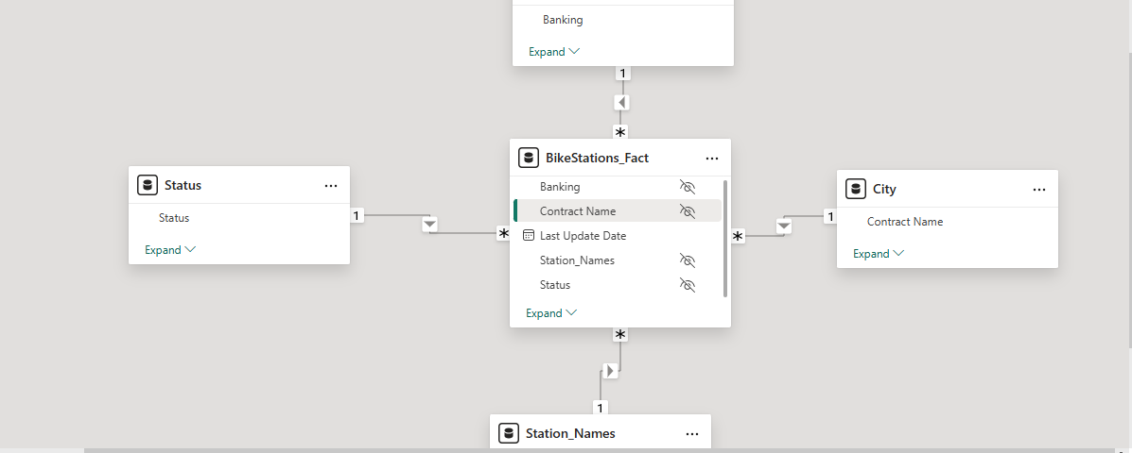

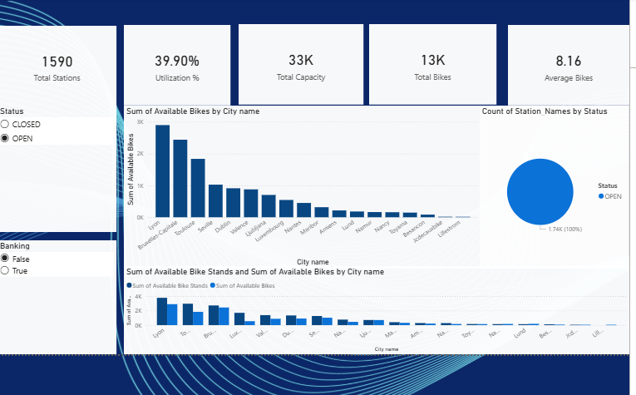
Here are clear insights you can write from your dashboard built in Microsoft Power BI.

Dashboard Insights

1️⃣ Total Stations
The bike-sharing system contains 1,590 stations, indicating a wide network of bike stations across multiple cities.

2️⃣ Bike Utilization
The utilization rate is 39.90%, which means:
- Around 40% of the total capacity is currently occupied by bikes
- Many stations still have available parking stands, suggesting room for more bikes.

3️⃣ Total Bike Capacity
The network has a total capacity of approximately 33,000 bike stands, which defines the maximum number of bikes that can be accommodated across all stations.

4️⃣ Total Bikes Available
There are currently 13,000 bikes available across all stations.
This indicates that not all stands are filled, which aligns with the utilization rate.

5️⃣ Average Bikes per Station
Each station has about 8.16 bikes on average.
This suggests:
- Medium bike distribution across stations
- Some stations may experience higher demand or shortages.

City-Level Insights

6️⃣ Cities with Highest Bike Availability
From the bar chart:
Cities such as Lyon, Toulouse, and Dublin have the highest number of available bikes.
This indicates:
- Larger bike-sharing networks
- Higher station density.

7️⃣ Smaller Networks
Cities such as Luxembourg and Nancy have relatively lower bike availability, indicating smaller bike-sharing systems.

Station Status

8️⃣ Operational Status
The pie chart shows 100% of stations are currently OPEN, meaning the system is fully operational with no closed stations.

Capacity vs Availability

9️⃣ Bike Stand Usage
The comparison chart shows that available bike stands are generally higher than available bikes, indicating:
- Many stations still have empty docking spaces.
- Bike demand may be high in certain locations.

Overall Conclusion
The dashboard shows that the bike-sharing system is widely distributed with strong operational availability. However, the utilization rate suggests that capacity is underused, indicating potential opportunities to optimize bike distribution across cities.
The analysis shows that the bike-sharing network operates across 1,590 stations with a total capacity of 33,000 stands. Currently, around 13,000 bikes are available, resulting in a utilization rate of nearly 40%. Major cities like Lyon and Toulouse contribute the highest number of bikes, while smaller cities show lower availability.

